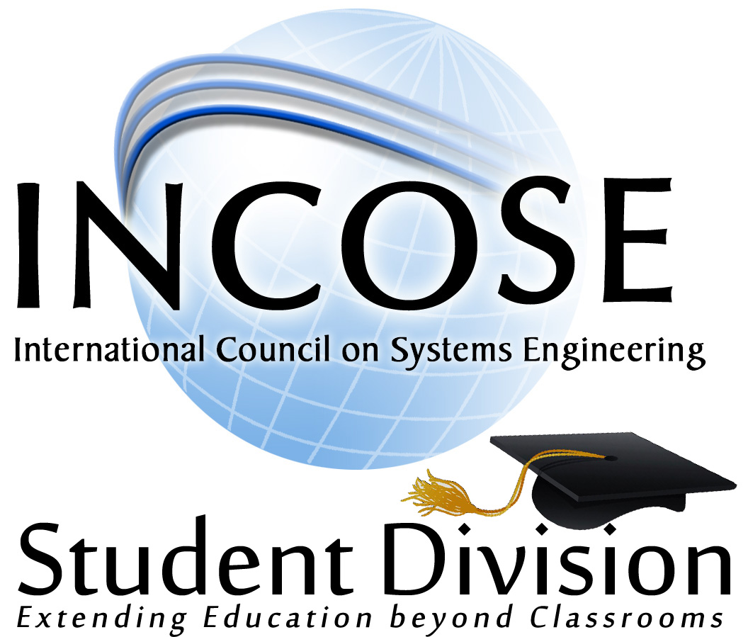
International Council on Systems Engineering
Student Division
Engineering Competition
Version 0.75 20120923

Student Division Program
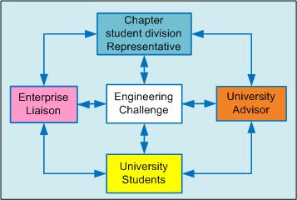
The Student Division program altered its student division model to integrate an ‘engineering challenge’ amongst the 4-Way Benefit Model Stakeholders as illustrated in Figure 1. This alteration is designed to accommodate student program across all international boundaries by

Figure 1: Student Division Mentoring network.

The Academic Forum met at the 2012 International Symposium where an overwhelming approval to create an Engineering Challenge (EC) and a EC Board (ECB)to develop the challenge, perform evaluation of submittals, and to select a winning entry. This represents the first EC competition to develop a project where the winning entry will be presented at the annual INCOSE International Symposium by the lead author.

Sponsors
The competition has two sponsors; the INCOSE Academic Matters and the INCOSE Lean Systems Engineering Working Group (LSE WG). These sponsors are represented on the ECB.

Competition Categories
Students have the option to select one of two competition categories with a single award offered to each category.
Category 1: Sponsored by the Academic Matters, competitors in this project will apply a ‘systems engineering methodology’ to develop a solution to a selected problem statement. The source of the problem statement is at the discretion of the student with concurrence by the student advisor. The submission for this project will be an electronic poster with a supporting white paper of not more than 3 pages.
Evaluations will be based on utilizing the ‘life cycle’ processes described in the INCOSE Systems Engineering Handbook, Version 3.2.

Category 2: Sponsored by the INCOSE Lean System Engineering Working Group (LSE WG) whose’ LEfSE project will utilize the concepts defined in the Lean Enablers for Systems Engineering and Lean Enablers for Managing Engineering Programs to describe the steps that technology programs should follow in order to reduce the program schedule and cost by 50% relative to the schedule and cost averaged in the programs of the last ten years. Submission will use A3 format and a 3 page white paper. Here the word ‘program’ refers to any program in which a student project can be adapted to and does not have domain specific, or industry, restrictions.
Evaluations will be based on applying the Lean Enablers noted in the above reference.

SDEC Submittals
Submittals will be:
- An electronic version of the A0 poster and ‘A Letter’ size white paper for evaluation.
- An A0 size poster using the INCOSE poster format established by the INCOSE IS planning committee for those posters to be displayed.
- The white paper will be format established by the INCOSE IS planning commission.
- Each submittal will be subject to the same publication quality standards imposed by the INCOSE Technical Operations for the IS proceedings. These standards can be found on the INCOSE website:
http://www.incose.org/ProductsPubs/symposia/paperguidelines.aspx

Publication
The SDEC recognizes the timing differences for students to develop a competitive project in time for submittal through the INCOSE Technical Operations for review, acceptance and publication in the INCOSE International Symposium (IS) proceedings.
These submittals will be:
- Published in an INCOSE IS addendum and distributed as a supplemental publication to attendees at the INCOSE IS.
- Posted to the INCOSE Student Division website for display, research, and review by members of INCOSE. Note Students, and other universities, will be able to view the posters and white papers, but will not be provided with download access (TBD). This is designed to provide visibility of the benefits of the student division program within INCOSE and to stimulate additional interest in the Student Division program.
- The electronic version of the poster along with a ‘2 minute elevator speech’ is being proposed to the 2013 IS planning committee to be viewed within the student division booth and at assorted location within the symposium. This will be developed and provided by the author, or team if there are multiple authors, for display at the IS.

SDEC Winner Award:
- Full sponsorship to the annual INCOSE International Symposium by the INCOSE Academic Matters.
- A financial reward by the LSE WG.
- Lead author to present their research in the Student Division Track (TBD) at the IS.
- The opportunity to present their research at the Student Division Panel and the Lean Systems Engineering Working Group.
- The EC winners’ poster and research paper will be prominently displayed inside the Student Division Exhibit booth for presentation and discussion with INCOSE members in attendance at the IS.

SDEC Submittal Recognitions
All submittals will be provided the following opportunities:
- A short video, ‘elevator speech’, developed by the author highlighting their research and the benefit of their participation in the EC. These will be displayed in the entry to the IS and within the Student Division Exhibit booth.
- The possibility to present their research during the student division track (TBD). Presentations will be limited to 15 minutes plus a 5 Minute Q&A. Presentations will utilize electronic power point files loaded onto the local computer according to the IS guidelines.
- Posters and Research Papers displayed on the Student Division Web site.
- Posters and Papers published in the INCOSE Student Division Addendum.

Target Timelines
The following table provides the dates and actions required to enable the EC to move forward and be incorporated into the upcoming academic program.

Date | Activity
31-Jul | Submit EC for review and comments by the ECB
31-Jul | Announce the selection of the ECB members
12-Aug | Incorporate comments into final SDEC program architecture
15-Aug | Present EC at the INCSOE BOD
1-Sep | Post EC to the INCOSE Student Division Website
31-Sep | Complete announcement of the EC to the INCOSE Universities
15 Oct | Receive proposals from Universities selecting to enter SDEC
31-Oct | Announce universities participating in the EC
30-Mar | Distribute evaluation assignments to ECB Members
16-Apr | Receive EC submittals to the Student Division Website
2-May | Announce EC winning entry

