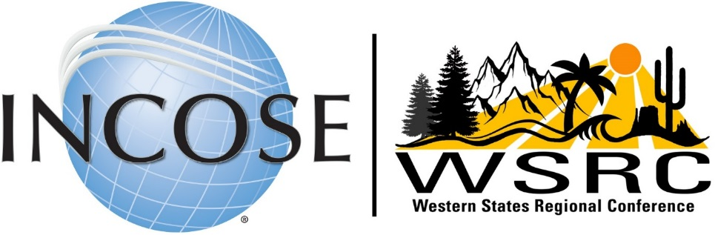

Save the Date: September 13-15, 2019

Loyola Marymount University, Los Angeles, CA

**Call for Sponsors**

The INCOSE western regional chapters will host the second annual Western States Regional Conference (WSRC) on Friday through Sunday, September 13-15, 2019, Loyola Marymount University, Los Angeles, CA.

This three-day event will feature keynote and technical presentations from systems engineering (SE) thought leaders, working groups and chapter leader meetings, panel discussions, and networking events and activities. In addition, the WSRC program will include an SE Professional Development Day (SE-PDD) on Saturday. This will be a virtual extension of the conference, with featured sessions broadcast to several remote (or satellite) sites.

The WSRC will provide superb opportunities to showcase your products and services. We expect on-site attendees—plus more remotely—from: aerospace, agriculture, automotive, biomedical & healthcare, defense, education, energy, government, information, infrastructure, safety and security, space, and transportation. These attendees will be key decision makers and systems engineers—the target market for your products and services.

We invite your organization to sponsor this regional event. Your sponsorship of the WSRC will be rewarded with multiple acknowledgements and benefits, as identified on the other side of this sheet. In addition, if you will tell us your needs and preferences, we can tailor sponsor benefits to suit.

**Western States Member and Social Outreach**

* 11 Chapters – WA, OR, AZ, CO, NM, CA, ID, NV & UT
* ~1500 active members & ~4500 inactive who receive chapter literature
* ~200 professional attendees expected in addition to the speakers & chapter hosts
* Additionally, the conference is posted on the corporate INCOSE website with ~20,000 followers

**INCOSE WSRC Sponsorship Levels for Organizations**



NOTES:

* For-profit organizations should select the Basic, Bronze, or higher levels.
* Professional societies should select the Professional Society level.
* Educational or non-profit organizations should select the Educator or Nonprofit level.

Tell us your needs and preferences. We can tailor sponsor benefits to suit!

**You can register for all sponsorship levels at**

For questions or comments, please contact

Paul Kostek, WSRC Sponsorship and Exhibits Chair, at [pjkostek@gmail.com](mailto:pjkostek@gmail.com) or  
Phyllis Marbach Conference Chair, [prmarbach@gmail.com](mailto:prmarbach@gmail.com)