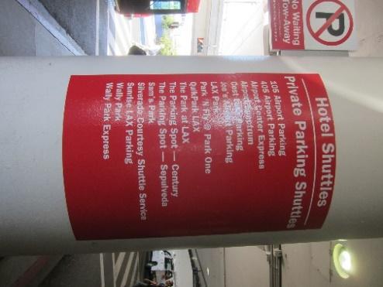
Flying to LAX and staying at the Renaissance?
Here is how to get to the hotel using the shuttle:

Leave your terminal on the lower level.
Look for the pedestrian island with the red sign on the pillar – that is the place to wait for the shuttle.
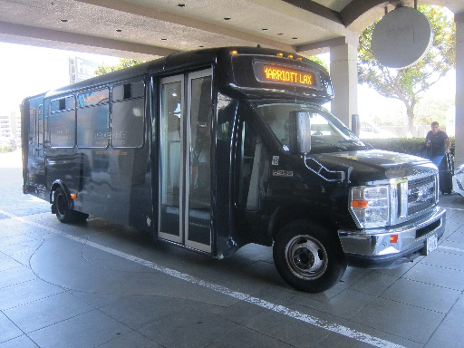
The shuttles are black and have Renaissance painted on the side. The destination board might say Marriott – the shuttles go to both places.
The shuttles run about every fifteen to twenty minutes.
The shuttles drop you off at the front door: walk on in, the hotel registration desk is around the corner to the left.

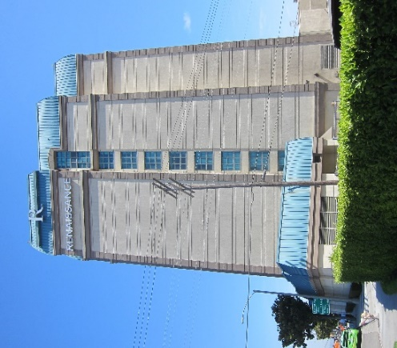
Driving to the Renaissance and want to use valet parking?
The Renaissance is located at southeast corner of 96th. Street and Airport Boulevard. Here is what you see when you get close, and when you get closer, approaching from the south (Century Boulevard) on Airport Boulevard.
Turn right into the driveway just beyond the taxi stand (don’t be surprised to see one of the airport shuttles) and stop in front of the door. A valet attendant will take if from there. Their rates are posted over the valet desk.
Walk on in, the hotel registration desk is around the corner to the left.
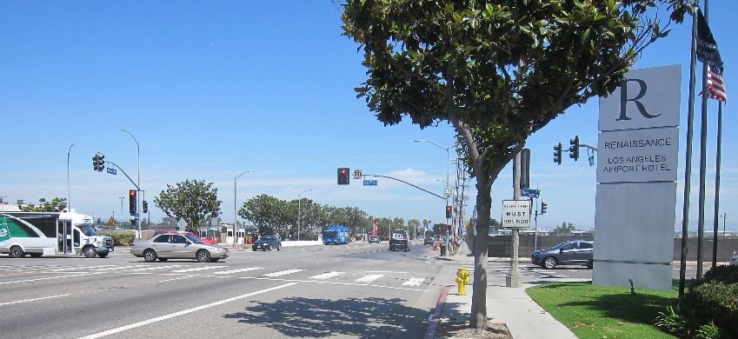
Airport Boulevard and 96th. Street, looking north.

Driving to the Renaissance and want to park yourself?
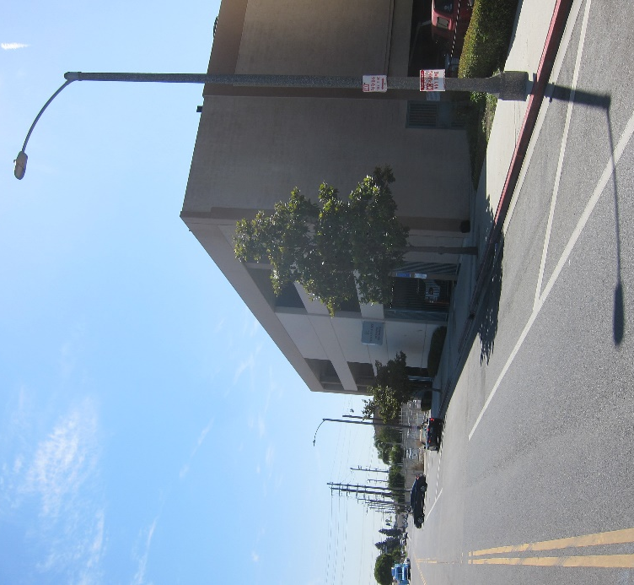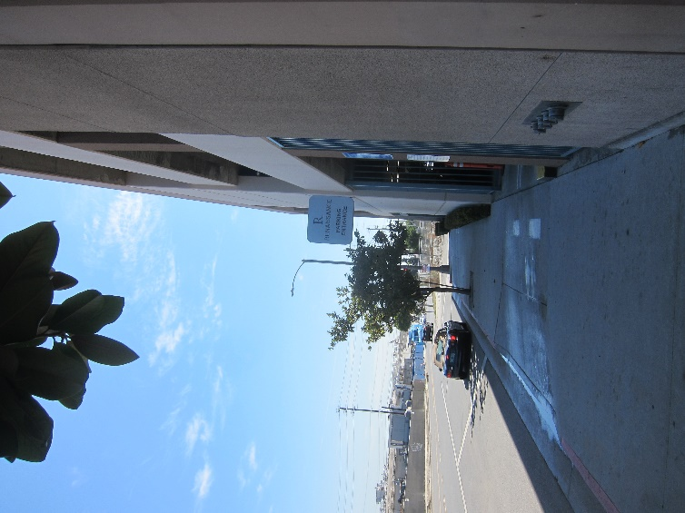
Same scenario as valet parking, except:
Continue on Airport Boulevard the short distance to 96th. Street.
Turn right on to 96th.
The parking garage is a short distance and has a sign.
Drive in, get a ticket to open the gate, park and then follow the signs into the hotel and the registration desk.
On-site parking, fee: 46.20 USD daily
Conference fee parking rate should be $20/day
Valet parking, fee: 53.90 USD daily

