Western States
Regional Conference

Systems Engineering Relevance:
Time for a Sea Change!

13-15 September 2019
Loyola Marymount University, Los Angeles, California

International Flavor ● Prominent Speakers ● Panels, Presentations, Tutorials
Systems Engineering Topics

- Model-Based Systems Engineering (MBSE)
- Agile Systems Engineering
- Current Perspectives in Systems Engineering
- Attracting and Developing Tomorrow’s Workforce
- Natural and Social Systems
- Systems Research and Analysis
- Application to Healthcare and Medical Devices

Convenient to Los Angeles International Airport!
For the latest information, including price and speakers, see
https://www.incose.org/wsrc2019
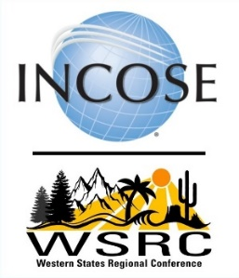

Hosted by the INCOSE Los Angeles Chapter
in collaboration with the Cascade,
Colorado Front Range, San Diego, San Francisco Bay Area,
Snake River, Seattle Metropolitan, and Wasatch chapters.
2019 Western States Regional Conference
Early bird rates available through August 15!
Meet Our Sponsors!
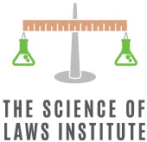
Our Technical Program
Friday
- Full Day Workshop (First Half): CSEP Examination Preparation Class (additional charge)
- Half Day Workshop honing soft skills: Systems Engineering to the Rescue
- Half-Day Tutorial: Correcting Misperceptions of Systems Engineering Practices
Saturday
- Multi-track Presentations and Panel Discussions
- Systems Engineering Professional Development Day (SE PDD) Track
  - Regional Remote Satellite Sites Will be Available
- Full Day Workshop (Second Half): CSEP Examination Preparation Class
- Networking Reception and Optional Dinner Banquet
  - Keynote Speaker: LtCol Kellie Brownlee, AF Space Future Ground Systems
Sunday
- Keynote Speaker: Dr. George Angeli, SE for Giant Telescope Observatories
- Multi-track Presentations and Panel Discussions
- Systems Engineering Professional Exam for INCOSE ASEP/CSEP Certification
- Optional Tour: NASA/Northrop-Grumman Webb Space Telescope (if accessible)
Location: Loyola Marymount University, Marina del Rey, Los Angeles, CA
Affordable 3-day registration fee includes lunches and mid-day breaks, hotel shuttle
A block of rooms has been reserved at The Renaissance Hotel, LA Airport
For further details and registration go to the WSRC website at:
https://www.incose.org/wsrc2019
Also an optional workshop (2 days: Thursday and Friday): Systems Engineering Bootcamp: Taking Systems Engineering to the Next Level
This Photo by Unknown Author is licensed under CC BY-SA-NC
This Photo by Unknown Author is licensed under CC BY-SA-NC
INCOSE is the International Council on Systems Engineering, https://www.incose.org/

